|  |
| --- |
| [Date] 15OCT2024 |

|  |
| --- |
| DEPLOYING A STATIC WEBSITE INTO AZURE USING AZURE SERVICES |

# **Project Details:**

1.Project Demo URL: https://healthcarehcwebstorage.z13.web.core.windows.net/

2.Project Video: Deploying of static Website on Azure (https://youtu.be/Y1LpiJZf2NU)

3.GitHub Repository URL: https://github.com/midhathh/static-website-on-Azure-Cloud.git

**Roles and Responsibilities:**

1. Sarah Firdous & Ayesha Midhath Anam:

-Managed web development project.

-Deployment & maintenance of project infrastructure.

-Managing documentation process.

1. Dikshita & Kalyan:

-Responsible for collecting the data.

**Problem Statement:**

In today’s fast-paced healthcare industry, there is a growing demand for digital tools that provide efficient patient interaction, secure data management, and disaster recovery solutions. Healthcare providers need a system that can:

• Enable quick access to medical information.

• Handle patient queries and appointment bookings automatically.

• Ensure secure, compliant storage of patient data.

• Provide robust data backup and recovery in case of data loss or security breaches.

Without a well-integrated solution, healthcare organizations risk data loss, non-compliance with regulatory standards, and inefficiencies in patient management.

### **Project Description:**

This project involves building a healthcare website that provides users (patients and healthcare professionals) with essential healthcare services and features, including a

- chat-bot for patient interaction,

- secure storage for medical data,

- automated backup for disaster recovery,

- seamless hosting via Azure’s infrastructure.

- Azure App Service for hosting a website,

Core Components are

1. Healthcare Website

2. Azure Storage Account

3. Azure AI BOT Service

4. Azure Backup Vault Service

5. App Service

6. Azure Subscriptions

### **Azure Services Used:**

To achieve the goals of this project, the following Azure services will be utilized:

1. **Azure Storage Account:**

• Purpose: Azure Storage Accounts will be used to store large amounts of unstructured data, such as medical images (e.g., X-rays, MRI's), medical records of the patients, and scanned documents.

• Details: Azure Backup Service is a cloud-based designed to back up and restore data in the Microsoft cloud ecosystem.

1. **Azure Blob Storage:**

• Purpose: Store unstructured data like medical images, documents, and large files.

• Details: Azure Blob Storage allows for secure and cost-effective storage of large amounts of unstructured data, ensuring medical records and imaging data are properly archived.

**3. Azure Backup Vault**:

• Purpose: Securely backup critical data including databases and files.

• Details: The Azure Backup Vault offers automated backups and point-in-time recovery for databases, ensuring that patient data and other critical application data can be restored in case of corruption, deletion, or other disasters.

**4. Azure Bot Service**:

• Purpose: Provide the chat-bot that interacts with patients.

• Details: This service will handle appointment bookings, answer medical FAQs, and provide basic healthcare guidance.

**5. Azure App Service:**

• Purpose: Host the healthcare website, which includes the chat-bot and API back-end.

• Details: Azure App Service provides a secure platform for hosting web applications.

1. **Azure Subscriptions:**

•Purpose: Resource Management, billing, access control, service limits, scalability, compliance and governance.

• Details: An Azure subscription is a logical container used to organize and manage Azure resources. Also it several key purposes.

### **Screenshots:**

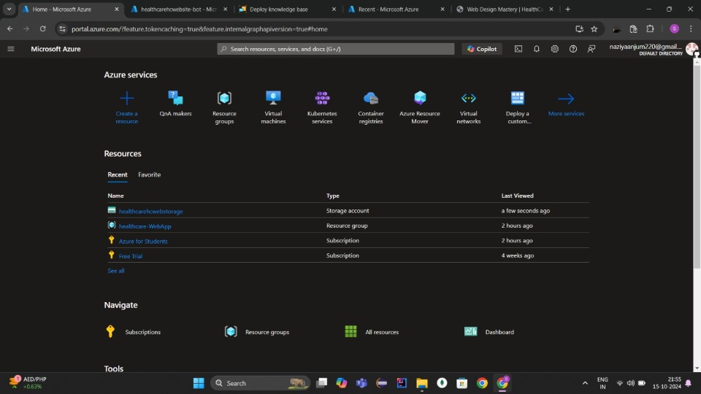

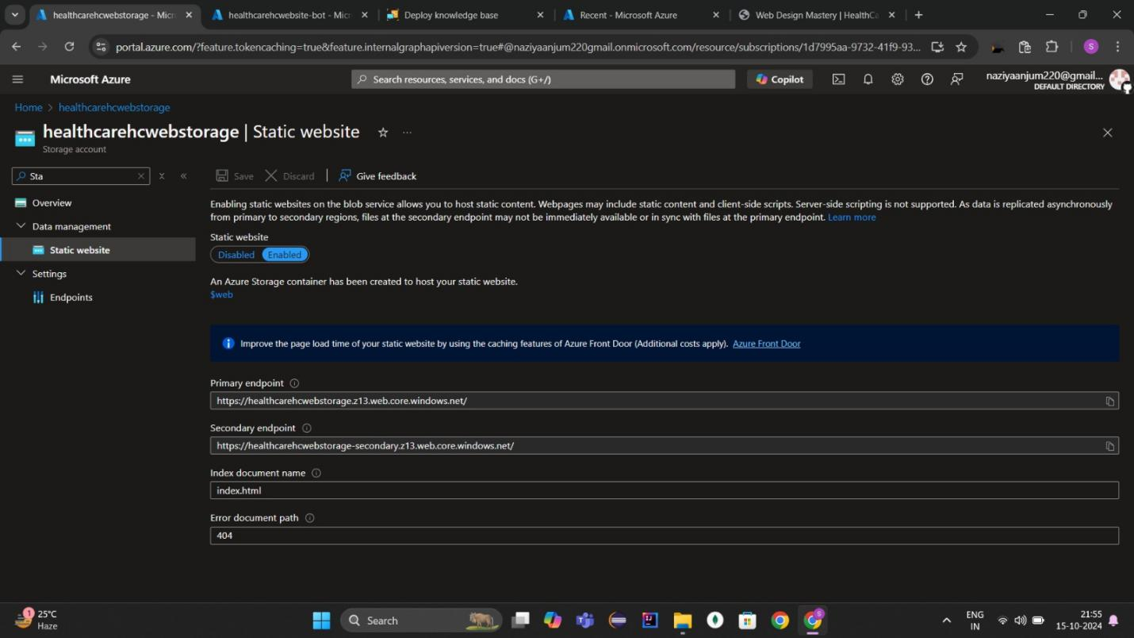

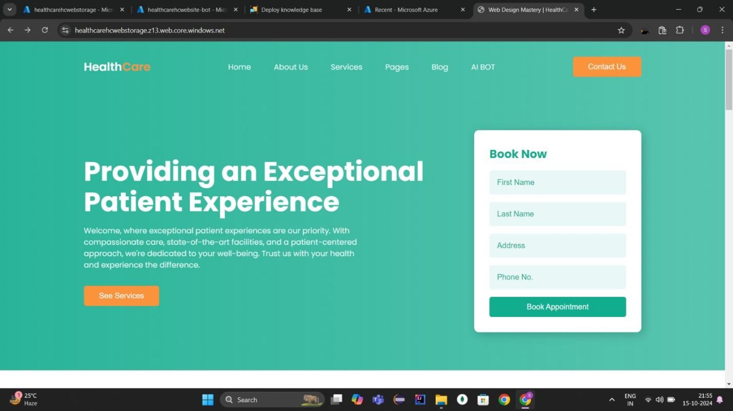

### **Conclusion:**

This documentation provides an overview of the problem, solution, and Azure services used for implementing a healthcare website with chat-bot and backup services. You can further expand on each section with more technical details depending on your implementation requirements.